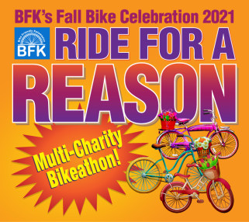
FOR IMMEDIATE RELEASE

Contact:
Paul Selden, Chair
Fall Bike Celebration 2021
fbc@bikefriendlykalamazoo.org
(269) 598-8301 (cell)
Big Multi-Charity Ride Rolling Into Town This Fall
More Than A Dozen Charities Participating In New Event

Kalamazoo, MI -- July 8, 2021 More than a dozen charities are participating in a big new fundraising event on September 18, 2021 from 9am-noon during Bike Friendly Kalamazoo’s third annual Fall Bike Celebration Weekend. The ride will start and end at the timber-framed Vicksburg Community Pavilion next to the Vicksburg Historic Village and has its own web page at https://fallbikecelebration.org/multi-charity-bikeathon/.

Participating Charities were invited by non-profit traffic safety and bicycle education advocate Bike Friendly Kalamazoo (BFK), with proceeds to support local and regional non-profits at a time when many have been hard-pressed. Thousands of dollars have already been raised by a group of Pacesetter sponsors, led by The Mill At Vicksburg, with additional support from The Vicksburg Foundation. The Participating Charities include:
Communities In Schools of Kalamazoo
Generous Hands, Inc.
JDRF – Juvenile Diabetes Research Foundation
Kalamazoo Valley Habitat for Humanity
Kazoo Valley AMBUCS
Mental Health Foundation of West Michigan / be nice. Program
Michigan Blind Athletic Association
Ministry with Community, Inc.
Open Roads Bike Program
Paper Technology Foundation
South County Community Services
Susan Mast ALS Foundation
Vicksburg Historical Society
Vicksburg Lions Club
YWCA Kalamazoo
… together with Bike Friendly Kalamazoo.

Bike Friendly Kalamazoo was motivated to organize the event earlier this year. “Call it an epiphany,” said its president, Paul Selden. “This winter people were struggling in so many ways. We realized that we could use our experience to support many causes all at once by creating a new, wholesome outdoor event that would be much less likely to be impacted by health concerns. To my great personal satisfaction, the leadership of the Participating Charities agreed! As a result, we see BFK’s Ride For A Reason as a way to build community through bicycling.”

More news about BFK’s Fall Bike Celebration 2021 will be released over the summer. More information can be found at www.fallbikecelebration.org.

###

Bike Friendly Kalamazoo (BFK) is a Michigan non-profit corporation whose network of volunteers is drawn from throughout greater Kalamazoo and whose mission is to help make our entire community even more bicycle friendly. Its vision is to help communities, businesses and schools achieve recognition as Bicycle Friendly through collaboration and by leveraging the area’s many resources via collegial action, supplementing existing resources with grants, scholarships, information-sharing and encouragement. For more information, please see www.bikefriendlykalamazoo.org.
###
This spectacular poster provided courtesy of in-kind sponsor Consort Display Group.

